Jyle Darling

M093437

Testing Documentation

AT3

Table of Contents

Test Evaluation and Fixes 1

Test Cases 2

Test Case Images 4

Case 01. 4

Case 02. 5

Case 03. 6

Case 04. 7

Case 05. 8

Case 06. 9

Case 07. 10

Case 08. 12

JUnit Test Cases 13

JUnit Test Case Images 14

# Test Evaluation and Fixes

# Test Cases

|  |  |  |  |  |
| --- | --- | --- | --- | --- |
| **Test Case** | **Description** | **Expected Result** | **Actual Result** | **Comments** |
| 01. | Server - Creating a new user in server application | User details added to list via a class object, message box to display showing user was added successfully. | As expected. | Ref figures 1, 2, and 3. |
| 02. | Server - Starting server socket connection | Pressing the server on starts the server connection. Start button becomes inactive, Stop button becomes active. | As expected. | Ref figures 4, 5 and 6. |
| 03. | Server - Stopping the server connection | Pressing the server off button stops the server connection, stop button becomes inactive, and start button becomes active. | As expected. | Ref figures 7, 8 and 9. |
| 04. | Client – Login attempt when server not connected. | Message to show connection issue. | As expected | Ref figures 10 and 11. |
| 05. | Client – Login attempt invalid credentials while server is connected. | Message to show login failed due to invalid credentials. | As Expected. | Ref figures 12 and 13. |
| 06. | Client – Login attempt valid credentials server connected. | Media Player application to load | As expected. | Ref figures 14 and 15. |
| 07. | Client – Opening CSV file containing song playlist via menu bar item. | Menu bar item to open an open file dialog, selecting the CSV file will populate the List box with file contents. Songs will play if selected. | As expected. | Ref figures 15, 17 and 18. |
| 08. | Client – Adding new songs to the playlist | Add new song button will open an open file dialog allowing one or more files to be added to the playlist. Song list will be sorted. | As expected. | Ref figures 19, 20 and 21. |
| 09. | Client – playing a song by double clicking the item in the list box | Double clicking an item in the list box will cause it to be played in the media player | As expected. | Ref figure 22. |
| 10. | Client – Removing a song from the list box | Selecting a song in the list and pressing remove selected song button will remove the song from the list. | As expected | Ref figures 23 and 24. |
| **Test Case** | **Description** | **Expected Result** | **Actual Result** | **Comments** |
| 11. | Client – Removing a song from the list box with nothing selected. | Pressing the remove selected song button with no list item selected will not do anything. | As expected. | Ref figure 25. |
| 12. | Client – Searching for a song in the list | Searching for a song in the list will highlight the song and cause it to start playing | As expected. | Re figures 26 and 27. |
| 13. | Client – Searching for a song not in the list | Nothing new will be highlight or played by the media player, message to display showing nothing found. | As expected. | Ref figures 28 and 29. |
| 14. | Saving a playlist to a csv file | Menu bar item will open a save file dialog which allows the contents of the list box to be saved to a CSV file | As expected. | Ref figures 30, 31 and 32. |
| 15 | Loading recently saved file to ensure data was saved correctly | Menu bar item to open an open file dialog, selecting the CSV file will populate the List box with file contents. Songs will play if selected. | As expected. | Ref figures 33, 34 and 35. |
| 16 | Opening the Help file | Selecting the help option from the menu bar will open the help.txt file. | As expected | Ref figures 36 and 37. |

# Test Case Images

### Case 01.

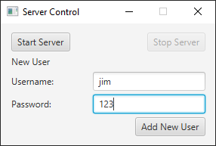

Figure 1

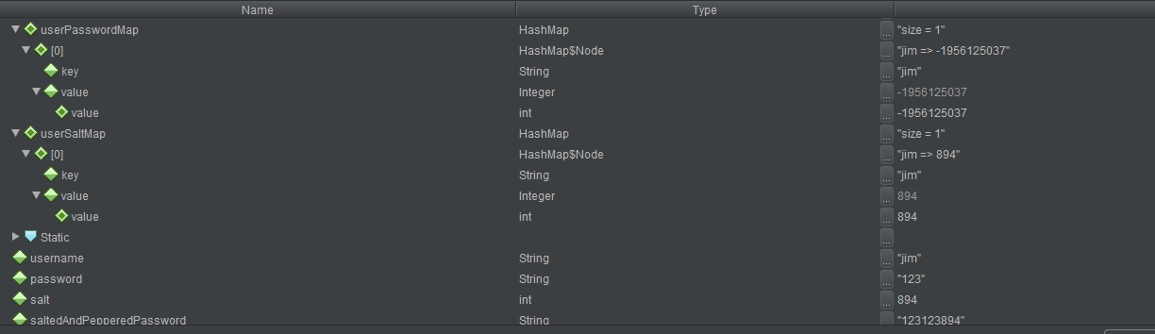

Figure 2

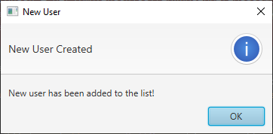

Figure 3

### Case 02.

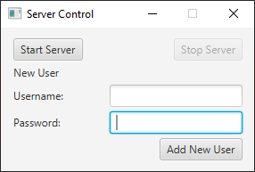

Figure 4

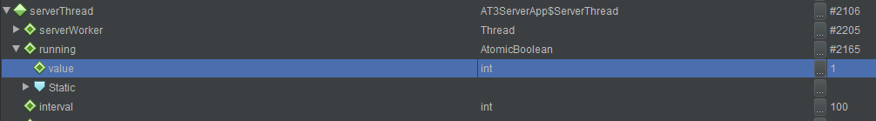

Figure 5

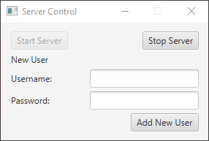

Figure 6

### Case 03.

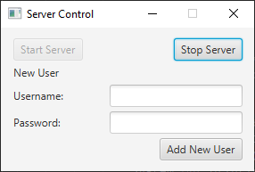

Figure 7

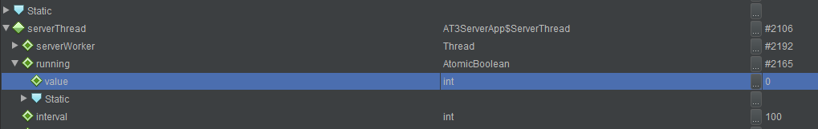

Figure 8

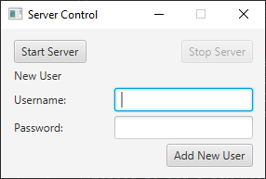

Figure 9

### Case 04.

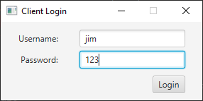

Figure 10

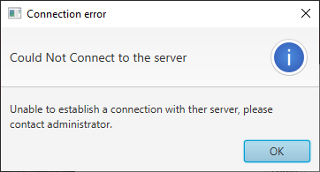

Figure 11

### Case 05.

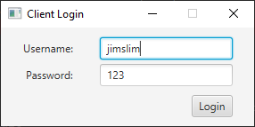

Figure 12

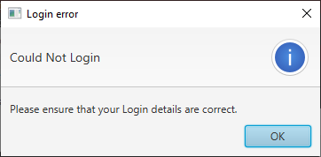

Figure 13

### Case 06.

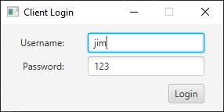

Figure 14

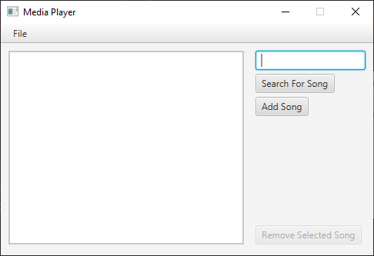

Figure 15

### Case 07.

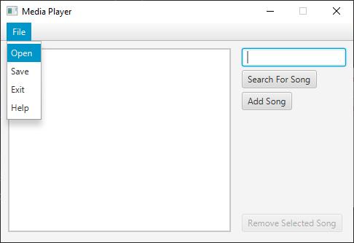

Figure 16

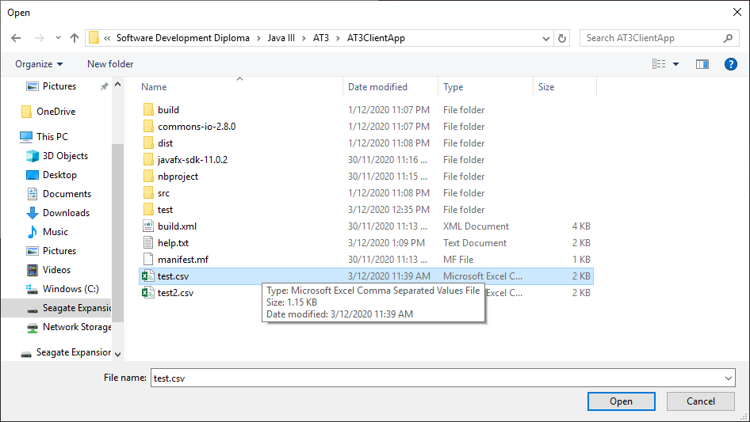

Figure 17

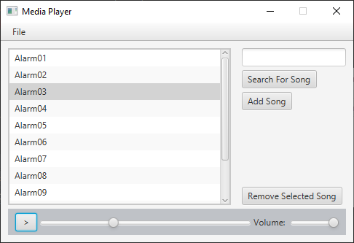

Figure 18

### Case 08.

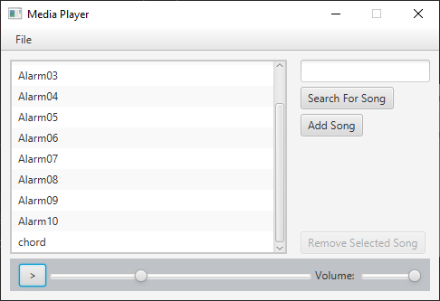

Figure 19

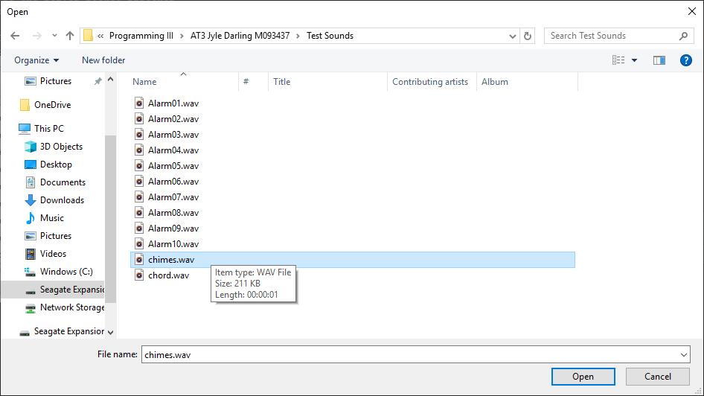

Figure 20

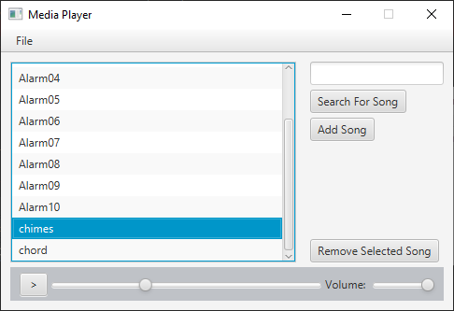

Figure 21

### Case 09.

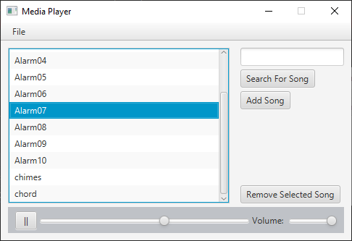

Figure 22

### Case 10.

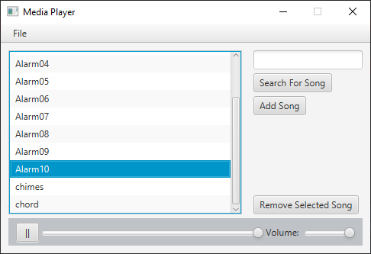

Figure 23

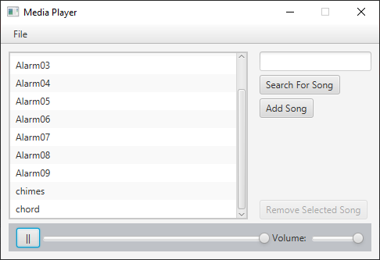

Figure 24

### Case 11.

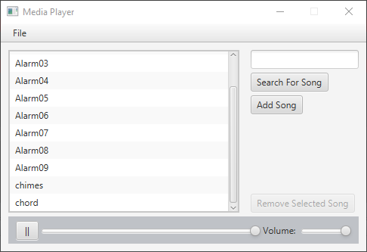

Figure 25

### Case 12.

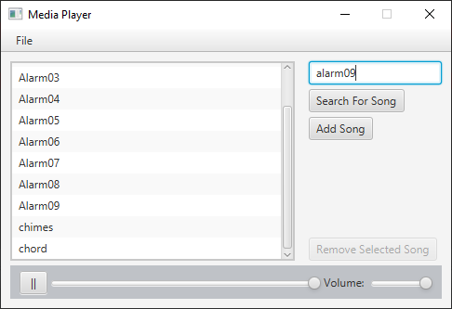

Figure 26

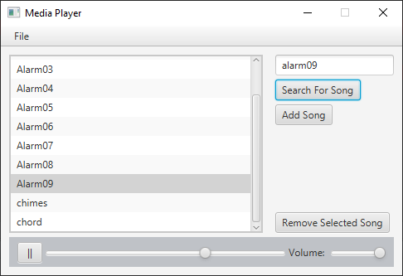

Figure 27

### Case 13.

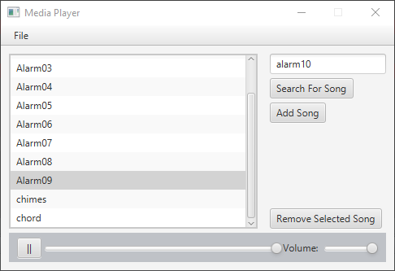

Figure 28

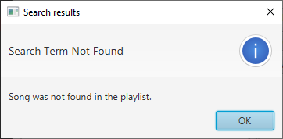

Figure 29

### Case 14.

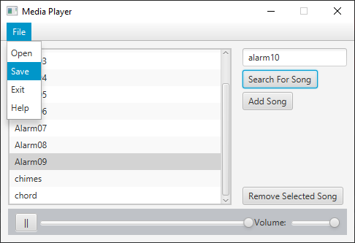

Figure 30

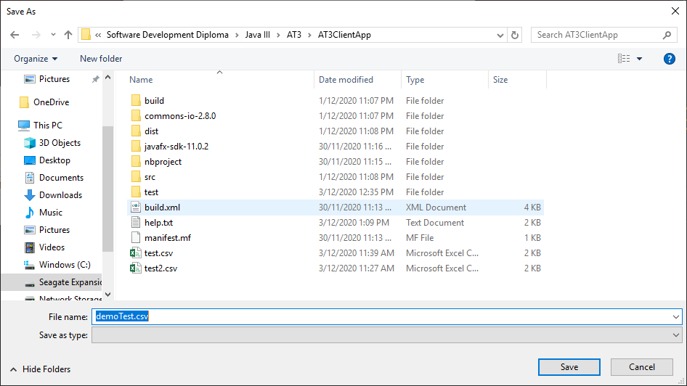

Figure 31

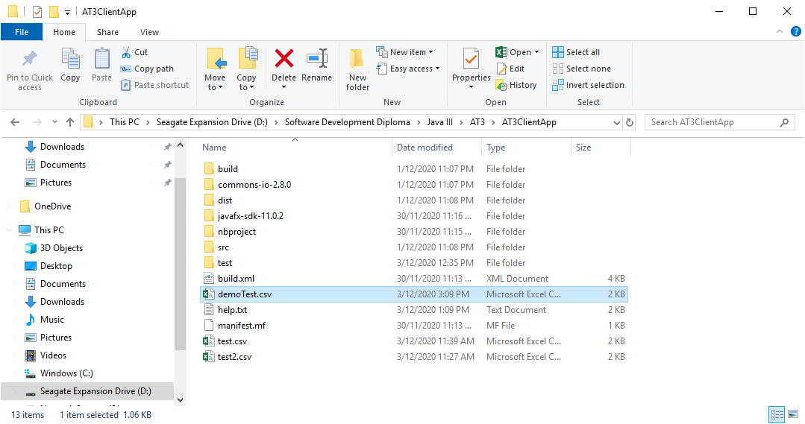

Figure 32

### Case 15.



Figure 33

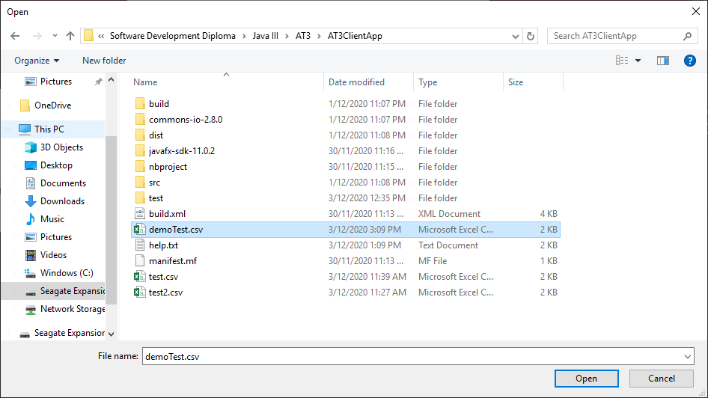

Figure 34

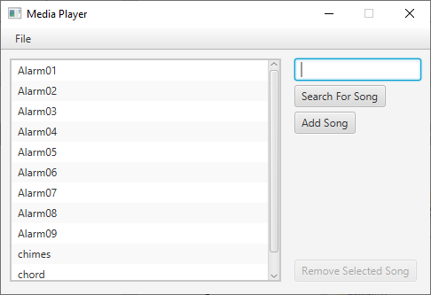

Figure 35

### Case 16.

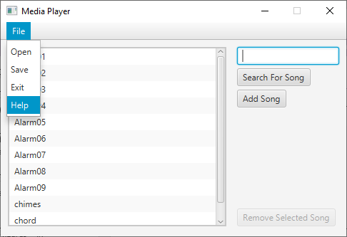

Figure 36

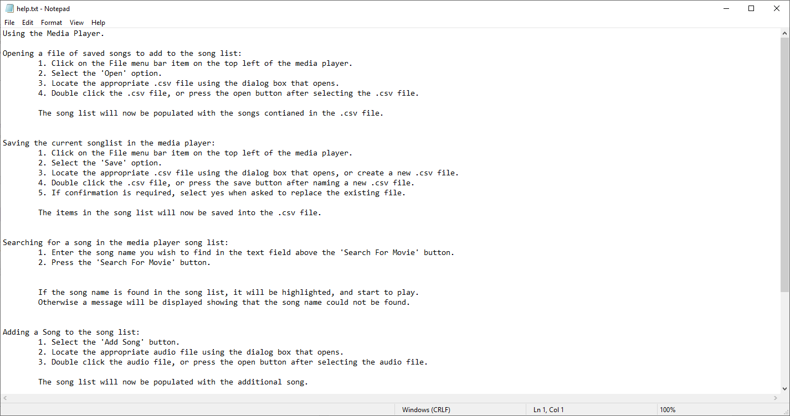

Figure 37

# JUnit Test Cases

# JUnit Test Case Images